Most common machine learning algorithms

The most common machine learning algorithms, their types, and the tasks they are best suited for, such as prediction, classification, regression, or clustering:

1. Linear Regression (LR)
- Type: Supervised
- Task: Regression
- Use Case: Predicting continuous numerical outcomes (e.g., house prices, sales figures).

2. Logistic Regression (LGR)
- Type: Supervised
- Task: Classification
- Use Case: Binary or multi-class classification problems (e.g., spam detection, disease diagnosis).

3. Decision Tree (DTY)
- Type: Supervised
- Task: Classification and Regression
- Use Case: Easily interpretable models for either categorical outcomes (classification) or numerical outcomes (regression).

4. Random Forest (RF)
- Type: Supervised
- Task: Classification and Regression
- Use Case: Complex problems requiring high accuracy, such as sentiment analysis, medical diagnosis, or price prediction.

5. K-Nearest Neighbors (KNN)
- Type: Supervised
- Task: Classification and Regression
- Use Case: Situations where data has clear clusters or boundaries (e.g., recommendation systems, image recognition).

6. Naive Bayes (NB)
- Type: Supervised
- Task: Classification
- Use Case: Text classification (e.g., spam filters, sentiment analysis) or where independence assumptions hold.

7. Support Vector Machine (SVM)
- Type: Supervised
- Task: Classification and Regression
- Use Case: Problems with a clear margin of separation (e.g., image classification, bioinformatics).

8. K-Means Clustering
- Type: Unsupervised
- Task: Clustering
- Use Case: Grouping data points into clusters based on similarity (e.g., customer segmentation, anomaly detection).

9. Principal Component Analysis (PCA)
- Type: Unsupervised
- Task: Dimensionality Reduction
- Use Case: Simplifying datasets while retaining significant patterns (e.g., preprocessing for visualization or faster computation).

10. Gradient Boosting Machines (GBMs)
- Examples: XGBoost, LightGBM, CatBoost
- Type: Supervised
- Task: Classification and Regression
- Use Case: Complex tasks requiring robust performance and feature importance interpretation (e.g., Kaggle competitions).

11. Neural Networks (NN)
- Type: Supervised and Unsupervised
- Task: Classification, Regression, and Generative tasks
- Use Case: Tasks involving images, text, or large datasets requiring high levels of abstraction (e.g., image recognition, natural language processing).

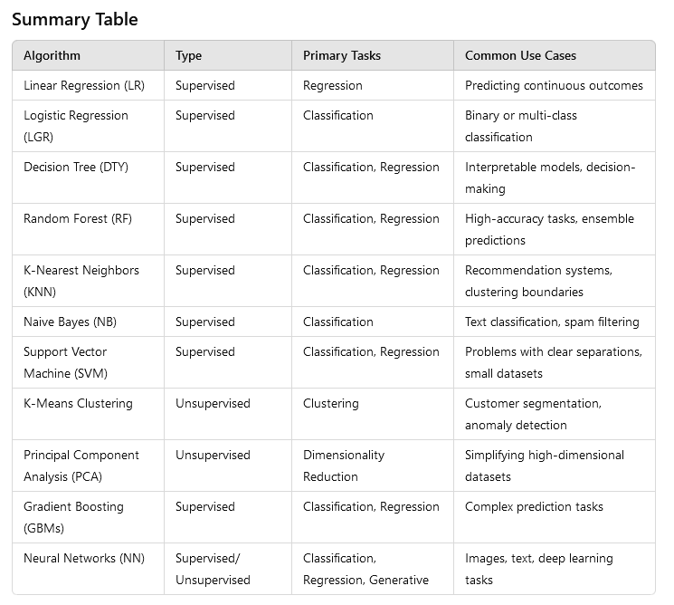

This categorization helps determine the most appropriate algorithm based on the nature of the task (prediction, classification, clustering, etc.) and the data at hand.

